1. Why is ABAP List Viewer (ALV) used?

The common desired features of any report are "column alignment", sorting, filtering, subtotals, totals etc. To implement these from scratch (in classical report), a lot of coding effort is to be put. To avoid that we can use a concept called ABAP List Viewer (ALV).

ALV gives us a standard List format and user interface to all our ABAP reports. ALV is created by a set of standard function modules provided by SAP.

ALV provides a lot of inbuilt functions to our reports and some of the functions are listed below.

* Sorting of records
* Filtering of records
* Totals and Sub-totals
* Download the report output to Excel/HTML
* Changing the order of the columns in the report
* Hide the unwanted columns from the report

Because of the above functions, ALV substantially decreases the report development time.

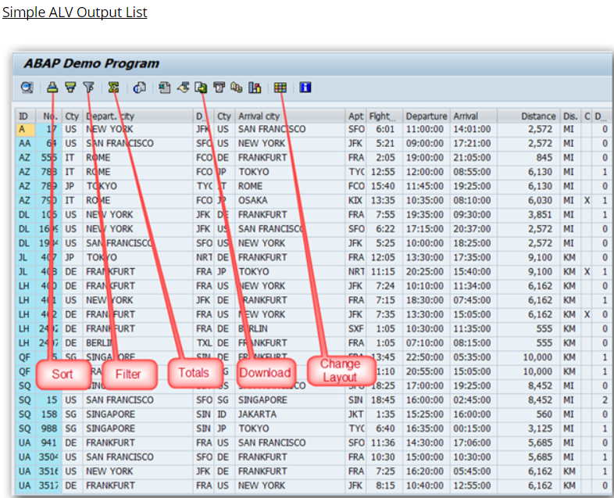

The SAP List Viewer is a generic tool that outputs data in a table form (rows and columns), with integrated functions to manipulate output (sort, totals, filter, column order, hide, etc.) and export it (Excel, Crystal report, CSV files, etc.) It is also possible to make ALV editable via ALV control.

1. What is Batch Data Communication?

Batch input is used to transfer data from non-R/3 systems to R/3 systems or to transfer data between R/3 systems.  
  
It is a data transfer technique that allows you to transfer datasets automatically to screens belonging to transactions, and thus to an SAP system. Batch input is controlled by a batch input session.

It is a technique for mass input of data by simulating user inputs in screens of existing transactions. Screens are not displayed; it can be run in the background. You do not bypass any of the standard SAP consistency checks, authorizations, etc.

In BDC the data will be loaded into R/3 using SAP Screen which we use to create a record (Example: Material in MM01). In simple BDC is a technique in SAP, which is used to upload mass data into R/3 server from a flat file (.txt, Excel etc.).

1. What are the two methods of performing BDC?

BDC can be performed in two methods:

* Call Transaction
* Session Method

1. What is Session Method in BDC?

This is also called as “classical batch input” or” Classical BDC”.

In it, an ABAP program reads the external data that is to be entered in the SAP System and stores the data in a “BDC session.” A session stores the actions that are required to enter your data using normal SAP transactions.

After creating the session, you can run the session to execute the SAP transaction in it. This method uses the function modules BDC_ OPEN, BDC_INSERT and BDC_CLOSE.

1. What are the processing modes in Batch Input Session?

Batch Input Session can be process in 3 ways

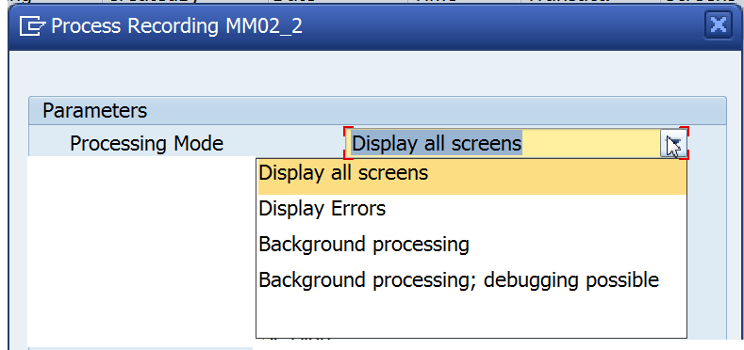

* In the foreground - Display All Screens
* In the background - Background processing
* During processing, with error display - Display Errors

You should process batch input sessions in the foreground or using the error display if you want to test the data transfer.

If you want to execute the data transfer or test its performance, you should process the sessions in the background.

1. What is call Transaction Method in BDC?

In this type of method your program will use the ABAP statement CALL TRANSACTION USING to run a SAP transaction. In this type external data need not be deposited in a session for being processed later. Instead, the entire batch input process takes place inline in your program.

1. Do we need to write code in LSMW?

Generally, No. In some cases, coding may be done.

1. How do you handle errors in session method?

Create and Process Sessions: Use BDC_OPEN_GROUP, BDC_INSERT, and BDC_CLOSE_GROUP to create and manage sessions.

Error Handling: Analyze session logs in SM35, correct errors, and reprocess the session.

In ABAP, the session method is used for batch input processing, where data is transferred to the SAP system in the form of sessions. Handling errors in the session method involves several steps to ensure that any issues encountered during the batch input process are properly managed and resolved.

Steps to Handle Errors in Session Method

Create the Session:

Use the BDC_OPEN_GROUP function module to create a new session.

Use the BDC_INSERT function module to add transactions to the session.

Use the BDC_CLOSE_GROUP function module to close the session.

Process the Session:

Sessions can be processed manually using transaction SM35 (Batch Input: Session Overview).

Alternatively, sessions can be processed programmatically using the BDC_PROCESS_SESSION function module.

Error Handling:

Log Analysis: After processing the session, analyze the session log in SM35 to identify any errors. The log provides detailed information about the errors encountered during processing.

Error Correction: Correct the errors based on the information provided in the log. This may involve fixing data issues, correcting transaction sequences, or addressing authorization problems.

Reprocess the Session: Once the errors are corrected, reprocess the session to ensure that all data is successfully posted.

Example of Creating and Processing a Session

DATA: lt_bdcdata TYPE TABLE OF bdcdata,

ls_bdcdata TYPE bdcdata,

lv_session TYPE c LENGTH 12 VALUE 'MY_SESSION'.

* Open a new session

CALL FUNCTION 'BDC_OPEN_GROUP'

EXPORTING

client = sy-mandt

group = lv_session

keep = 'X'

user = sy-uname

EXCEPTIONS

OTHERS = 1.

* Insert transactions into the session

ls_bdcdata-program = 'SAPMF02D'.

ls_bdcdata-dynpro = '0100'.

ls_bdcdata-dynbegin = 'X'.

APPEND ls_bdcdata TO lt_bdcdata.

ls_bdcdata-fnam = 'BDC_OKCODE'.

ls_bdcdata-fval = '/00'.

APPEND ls_bdcdata TO lt_bdcdata.

CALL FUNCTION 'BDC_INSERT'

EXPORTING

tcode = 'FB01'

TABLES

dynprotab = lt_bdcdata

EXCEPTIONS

OTHERS = 1.

* Close the session

CALL FUNCTION 'BDC_CLOSE_GROUP'

EXCEPTIONS

OTHERS = 1.

* Process the session (optional, can also be done manually in SM35)

CALL FUNCTION 'BDC_PROCESS_SESSION'

EXPORTING

session = lv_session

EXCEPTIONS

OTHERS = 1.

1. How do you handle errors in call transaction method?

We can handle the errors with BDCMSGCOLL where we can display the errors.

In ABAP, the CALL TRANSACTION method is used to execute a transaction code programmatically. Handling errors in this method involves capturing and analyzing the messages returned by the transaction. Here’s how you can handle errors effectively:

Steps to Handle Errors in CALL TRANSACTION Method

Prepare the BDC Data:

Create an internal table of type BDCDATA to hold the batch input data.

Call the Transaction:

Use the CALL TRANSACTION statement with the USING addition to pass the BDC data.

Use the MODE addition to specify the processing mode (A for display all screens, E for display errors only, N for no screens).

Use the UPDATE addition to specify the update mode (S for synchronous, A for asynchronous, L for local).

Capture Messages:

Use the MESSAGES INTO addition to capture messages in an internal table of type BAPIRET2.

Analyze Messages:

Analyze the messages captured in the internal table to identify and handle errors.

Example

Here’s an example of how to handle errors using the CALL TRANSACTION method:

DATA: lt_bdcdata TYPE TABLE OF bdcdata,

ls_bdcdata TYPE bdcdata,

lt_messages TYPE TABLE OF bapiret2,

ls_message TYPE bapiret2.

* Prepare BDC data

ls_bdcdata-program = 'SAPMF02D'.

ls_bdcdata-dynpro = '0100'.

ls_bdcdata-dynbegin = 'X'.

APPEND ls_bdcdata TO lt_bdcdata.

ls_bdcdata-fnam = 'BDC_OKCODE'.

ls_bdcdata-fval = '/00'.

APPEND ls_bdcdata TO lt_bdcdata.

* Call the transaction

CALL TRANSACTION 'FB01' USING lt_bdcdata

MODE 'E'

UPDATE 'S'

MESSAGES INTO lt_messages.

* Analyze messages

LOOP AT lt_messages INTO ls_message.

WRITE: / ls_message-message.

ENDLOOP.

Explanation

Prepare BDC Data: The BDC data is prepared and stored in lt_bdcdata.

Call Transaction: The CALL TRANSACTION statement executes the transaction FB01 using the BDC data. The MODE 'E' option displays only screens with errors, and UPDATE 'S' ensures synchronous updates.

Capture Messages: Messages are captured into lt_messages.

Analyze Messages: The messages are looped through and displayed, allowing you to identify and handle any errors.

Summary

Prepare BDC Data: Create and populate the BDC data.

Call Transaction: Execute the transaction and capture messages.

Analyze Messages: Loop through the messages to identify and handle errors.

1. After the call Function Module how does the SY-SUBRC check happen?

In ABAP, after calling a function module, the system field SY-SUBRC is automatically set to indicate the success or failure of the function call. You can check the value of SY-SUBRC to determine the outcome and handle any errors or specific conditions accordingly.

**Steps to Check SY-SUBRC After Calling a Function Module**

1. **Call the Function Module**:
   * Use the CALL FUNCTION statement to invoke the function module.
2. **Check SY-SUBRC**:
   * Immediately after the function call, check the value of SY-SUBRC to determine the result.
3. What do you mean by client Dependent and Client independent?

Client-Dependent: Specific to a particular client, used for data and configurations that vary between clients.

Client-Independent: Shared across all clients, used for data and configurations that are consistent across the entire SAP system.

1. What is the difference between synchronous update and Asynchronous update?

Synchronous Update: The program waits for the update to complete. Use when immediate confirmation is needed.

Asynchronous Update: The program does not wait for the update to complete. Use when performance is prioritized and immediate confirmation is not required.

1. In smart forms, can you put a table in secondary window?

Yes, you can include a table in a secondary window in SAP Smart Forms. To do this, you need to create a secondary window and then insert a table node within that window. Here are the steps:

Create a Secondary Window: In the Smart Form, go to the navigation tree and create a secondary window.

Insert a Table: Within the secondary window, insert a table node.

Define Table Structure: Define the table structure, including the header, main area, and footer if needed.

Bind Data: Bind the table to the data source to populate it with the required information.

This allows you to display tabular data in a secondary window, which can be useful for organizing information in a structured format.

1. What will happen if the records are more than what can be accommodated in the secondary window?

If the records exceed the space available in the secondary window in SAP Smart Forms, the content will not automatically overflow to the next page. Instead, you need to handle this scenario manually. Here are a few approaches to manage this:

1. **Page Breaks**: You can define page breaks within the table to ensure that the content continues on the next page. This involves setting up conditions to trigger a new page when the current page is full.
2. **Looping Logic**: Implement looping logic to split the data across multiple pages. This can be done by controlling the output of the table rows and managing the flow to subsequent pages.
3. **Secondary Windows on Multiple Pages**: You can create secondary windows on multiple pages and control the flow of data between these windows.
4. **Dynamic Window Size**: Adjust the size of the secondary window dynamically based on the content, although this might require more complex scripting and logic.
5. What is the role of transport Request no in SAP Landscape?
6. How do upload image in smart forms?

To upload and display an image in SAP Smart Forms, follow these steps:

1. **Prepare the Image**: Ensure your image is in a supported format (e.g., BMP, TIFF, or JPG).
2. **Upload the Image to SAP**:
   * Go to transaction SE78 (SAP Graphics Management).
   * Select Graphic → Import.
   * Choose the appropriate folder (e.g., BMAP for bitmap images).
   * Click on Import and upload your image file.
3. **Create a Graphic Node in Smart Form**:
   * Open your Smart Form in transaction SMARTFORMS.
   * In the navigation tree, right-click on the node where you want to insert the image and select Create → Graphic.
   * In the properties of the graphic node, enter the name of the uploaded image.
4. **Adjust the Image Properties**: Set the size and alignment of the image as needed.
5. **Activate and Test**: Activate your Smart Form and test it to ensure the image is displayed correctly.
6. Can you upload image in background in smart forms?

Yes, you can upload and display an image in the background of a Smart Form in SAP. Here’s how you can do it:

1. **Upload the Image**:
   * Use transaction SE78 to upload your image to SAP as described earlier.
2. **Create a Background Graphic**:
   * Open your Smart Form in transaction SMARTFORMS.
   * In the navigation tree, create a new Graphic node where you want the background image to appear.
3. **Set the Graphic as Background**:
   * In the properties of the graphic node, enter the name of the uploaded image.
   * Adjust the size and position of the image to cover the desired background area.
4. **Layering Elements**:
   * Ensure that the graphic node is placed in the hierarchy before other elements that should appear on top of the background image.
5. **Adjust Transparency**:
   * If needed, adjust the transparency settings of the image to ensure that text and other elements are readable.
6. **Activate and Test**:
   * Activate your Smart Form and test it to ensure the background image is displayed correctly.
7. What is the difference between HANA and S4 HANA?

HANA is a DB. S4 HANA Is an ERP application just like ECC. SD, MM, PP all components are present in S4 HANA.

1. What is the difference in Row Store and Column Store?

The difference between Row Store and Column Store lies in how data is stored and accessed in a database. Here’s a detailed comparison:

Row Store

Storage Method: Data is stored row by row. Each row contains all the columns for that particular record.

Use Case: Ideal for transactional workloads where operations typically involve accessing a complete record (e.g., inserting, updating, or deleting records).

Performance: Efficient for operations that require reading or writing entire rows, as all the data for a record is stored together.

Example: Traditional relational databases like MySQL and PostgreSQL.

Column Store

Storage Method: Data is stored column by column. Each column contains all the values for that particular attribute across all records.

Use Case: Optimized for analytical workloads where operations often involve aggregating data from specific columns (e.g., calculating averages, sums).

Performance: Efficient for read-heavy operations that involve scanning and aggregating large datasets, as only the relevant columns are accessed.

Example: Analytical databases like SAP HANA and Amazon Redshift.

Key Differences

Data Access: Row Store is faster for accessing complete records, while Column Store is faster for accessing specific columns.

Compression: Column Store allows for better compression and indexing, as similar data types are stored together, reducing redundancy.

Query Performance: Column Store generally offers better performance for complex queries involving aggregations and filtering

1. What is the use of constructor?

In object-oriented programming, a constructor is a special type of method used to initialize objects. Here are the key roles and uses of a constructor:

1. **Initialization**: Constructors are used to set initial values for the object's attributes. When an object is created, the constructor ensures that the object starts in a valid state with all necessary properties initialized.
2. **Automatic Invocation**: Constructors are automatically called when an object is instantiated. This means you don't need to explicitly call the constructor; it runs as soon as the object is created.
3. **Dependency Injection**: Constructors can be used to inject dependencies into an object. By passing parameters to the constructor, you can ensure that the object has all the necessary dependencies it needs to function correctly.
4. **Overloading**: Many programming languages allow constructor overloading, meaning you can have multiple constructors with different parameters. This provides flexibility in how objects are created and initialized.
5. **Default Values**: If no constructor is defined, many languages provide a default constructor that initializes the object with default values. However, defining your own constructor allows you to set specific initial values.
6. What is the concept of In memory DB in SAP HANA?

The concept of an in-memory database in SAP HANA revolves around storing data directly in the main memory (RAM) rather than on traditional disk storage. This approach significantly enhances data processing speed and efficiency. Here are the key aspects of SAP HANA's in-memory database:

**Key Features**

1. **High-Speed Data Access**: By keeping data in RAM, SAP HANA eliminates the need for time-consuming disk I/O operations, allowing for real-time data processing and analytics
2. **Columnar Storage**: SAP HANA uses columnar storage, which organizes data by columns rather than rows. This format is highly efficient for read-heavy operations and analytical queries, as it allows for faster data retrieval and better compression
3. **Parallel Processing**: The architecture of SAP HANA supports massive parallel processing, leveraging multi-core processors to handle large volumes of data simultaneously. This ensures high performance and scalability
4. **ACID Compliance**: Despite being an in-memory database, SAP HANA maintains ACID (Atomicity, Consistency, Isolation, Durability) properties, ensuring data integrity and reliability even during concurrent transactions
5. **Real-Time Analytics**: The combination of in-memory storage and columnar data organization allows SAP HANA to perform complex analytical queries in real-time, providing immediate insights and supporting decision-making processes

**Benefits**

* **Speed**: In-memory computing can process data up to 10,000 times faster than traditional disk-based databases
* **Efficiency**: Reduced data redundancy and improved data compression lead to more efficient storage and faster query performance.
* **Flexibility**: SAP HANA supports both transactional (OLTP) and analytical (OLAP) workloads, making it a versatile solution for various business needs

1. Can we add CDS views in smart forms?

Yes, you can use CDS (Core Data Services) views in SAP Smart Forms, but it requires some additional steps since Smart Forms do not directly support CDS views. Here’s how you can integrate CDS views with Smart Forms:

1. **Create CDS View**: First, create your CDS view in the ABAP Dictionary. This view will define the data you want to display in your Smart Form.
2. **Expose CDS View via OData Service**:
   * Use transaction SEGW (SAP Gateway Service Builder) to create an OData service that exposes your CDS view.
   * Implement the necessary methods to read data from the CDS view.
3. **Consume OData Service in ABAP Program**:
   * Write an ABAP program to call the OData service and fetch the data from the CDS view.
   * Process the data as needed and pass it to the Smart Form.
4. **Pass Data to Smart Form**:
   * In your ABAP program, call the Smart Form and pass the fetched data to it.
   * Use the form interface to define the data structure that the Smart Form will receive.
5. **Design Smart Form**:
   * Design your Smart Form to display the data. Use table nodes or other elements to format the data as required.
6. How many main windows can a smart form have?

In SAP Smart Forms, you can have only one main window per form. The main window is used for displaying the main content that can flow across multiple pages. However, you can have multiple secondary windows, copies windows, and final windows to organize other content on your form.

1. What is the difference between Loop at top and loop in table in smart forms?

In SAP Smart Forms, both "Loop at Top" and "Loop in Table" are used to iterate over internal tables, but they serve different purposes and are used in different contexts. Here’s a detailed comparison:

Loop at Top

Usage: The "Loop at Top" is used to iterate over an internal table at the top level of the Smart Form. It is typically used to process and display data that is not structured in a tabular format.

Placement: This loop is placed directly in the main window or a secondary window, outside of any table node.

Flexibility: It provides more flexibility in terms of layout and formatting, as you can place various elements (texts, graphics, etc.) inside the loop.

Example: Useful for scenarios where you need to repeat a set of elements (like text blocks or graphics) for each entry in the internal table.

Loop in Table

Usage: The "Loop in Table" is specifically used within a table node to iterate over the rows of an internal table. It is designed to handle tabular data efficiently.

Placement: This loop is placed inside a table node, which is itself placed in the main window.

Structure: The table node has a predefined structure with header, main area, and footer sections. The loop iterates over the internal table and fills the main area with data.

Example: Ideal for displaying data in a tabular format, such as lists of items, invoices, or reports.

Key Differences

Context: "Loop at Top" is used for more general purposes and can include various elements, while "Loop in Table" is specifically for tabular data.

Layout: "Loop at Top" allows for a more flexible layout, whereas "Loop in Table" follows a structured table format.

Usage Scenario: Use "Loop at Top" for non-tabular data or when you need custom formatting for each loop iteration. Use "Loop in Table" for displaying data in a structured table format.

1. What is the concept of code push-down in HANA?

The concept of **code push-down** in SAP HANA involves moving data-intensive computations from the application layer to the database layer. This approach leverages the high-performance capabilities of the HANA database to process large volumes of data more efficiently. Here are the key aspects:

**Key Features**

1. **Data-to-Code Paradigm**: Traditional applications often bring data to the application layer for processing. Code push-down reverses this by pushing the computation down to where the data resides, in the database.
2. **Enhanced Performance**: By executing complex calculations and aggregations directly in the HANA database, you reduce the amount of data transferred between the database and application layers, leading to faster processing times.
3. **Utilizing HANA's Strengths**: HANA's in-memory computing and columnar storage are optimized for high-speed data retrieval and processing. Code push-down takes full advantage of these features.

**Implementation**

* **ABAP Managed Database Procedures (AMDP)**: These allow you to write database procedures in SQLScript, which are executed in the HANA database.
* **Core Data Services (CDS)**: CDS views enable you to define data models and push complex logic to the database layer.
* **Enhanced Open SQL**: New features in Open SQL allow for more complex queries and calculations to be performed directly in the database

.

**Benefits**

* **Reduced Data Transfer**: Minimizes the need to transfer large datasets to the application layer for processing.
* **Improved Scalability**: Efficiently handles large volumes of data, making it suitable for big data applications.
* **Real-Time Analytics**: Enables real-time data processing and analytics, providing immediate insights

By adopting code push-down, you can significantly enhance the performance and efficiency of your SAP applications, making better use of HANA's powerful capabilities.